Ex. No. : 02B Date: 14-02-2026
Register No.: 231701023 Name: S.V.Jashwanth

Scientific Calculator
Aim
To develop a scientific calculator application using Android Studio and Kotlin to perform basic arithmetic and scientific operations.

Procedure:
- Open Android Studio and create a new project using Empty Activity.
- Select Kotlin as the programming language.
- Design the layout using a TextView to display the result and Buttons for numbers, operators, and scientific functions.
- Arrange the buttons using LinearLayout in vertical and horizontal orientations for proper calculator design.
- Open the MainActivity.kt file and connect the TextView and all Buttons using findViewById.
- Write logic to append numbers and decimal points to the display when number buttons are pressed.
- Write logic to store the first number and selected operator when an operator button is pressed.
- Write logic to perform addition, subtraction, multiplication, and division when the equal button is pressed.
- Write logic to perform scientific operations such as sin, cos, tan, log, and square root using Kotlin math functions.
- Add clear button functionality to reset the calculator display and values.
- Run the application and verify that all arithmetic and scientific operations work correctly.

AndroidManifest.xml

<?xml version="1.0" encoding="utf-8"?>
<manifest xmlns:android="http://schemas.android.com/apk/res/android"
xmlns:tools="http://schemas.android.com/tools">
<application
android:allowBackup="true"
android:dataExtractionRules="@xml/data_extraction_rules"
android:fullBackupContent="@xml/backup_rules"
android:icon="@mipmap/ic_launcher"
android:label="@string/app_name"
android:roundIcon="@mipmap/ic_launcher_round"
android:supportsRtl="true"
android:theme="@style/Theme.CustomCalculatorDesign">
<activity
android:name=".MainActivity"
android:exported="true">
<intent-filter>
<action android:name="android.intent.action.MAIN" />
<category android:name="android.intent.category.LAUNCHER" />
</intent-filter>
</activity>
<meta-data
android:name="preloaded_fonts"
android:resource="@array/preloaded_fonts" />
</application>
</manifest>

Activity_main.xml

<?xml version="1.0" encoding="utf-8"?>
<LinearLayout xmlns:android="http://schemas.android.com/apk/res/android"
xmlns:app="http://schemas.android.com/apk/res-auto"
xmlns:tools="http://schemas.android.com/tools"
android:id="@+id/main"
android:layout_width="match_parent"
android:layout_height="match_parent"
android:background="#000000"
android:orientation="vertical"
tools:context=".MainActivity">
<TextView
android:id="@+id/txtResult"
android:layout_width="394dp"
android:layout_height="wrap_content"
android:layout_marginLeft="6dp"
android:layout_marginTop="200dp"
android:layout_marginRight="5dp"
android:background="#000000"
android:fontFamily="@font/cantata_one"
android:text="0"
android:textAlignment="textEnd"
android:textColor="#FFFFFF"
android:textSize="48sp" />
<LinearLayout
android:layout_width="match_parent"
android:layout_height="74dp"
android:layout_marginLeft="5dp"
android:layout_marginTop="60dp"
android:layout_marginRight="5dp"
android:orientation="horizontal">
<Button
android:id="@+id/btnC"
android:layout_width="192dp"
android:layout_height="match_parent"
android:layout_marginLeft="5dp"
android:layout_marginRight="5dp"
android:layout_weight="1"
android:backgroundTint="#FF9800"
android:text="C"
android:textSize="20sp"
app:cornerRadius="10dp" />
<Button
android:id="@+id/btnSin"
android:layout_width="wrap_content"
android:layout_height="match_parent"
android:layout_marginLeft="5dp"
android:layout_marginRight="5dp"
android:layout_weight="1"
android:backgroundTint="#303030"
android:text="SIN"
android:textSize="20sp"
app:cornerRadius="10dp" />
<Button
android:id="@+id/btnCos"
android:layout_width="wrap_content"
android:layout_height="match_parent"
android:layout_marginLeft="5dp"
android:layout_marginRight="5dp"
android:layout_weight="1"
android:backgroundTint="#303030"
android:text="COS"
android:textSize="20sp"
app:cornerRadius="10dp" />
</LinearLayout>
<LinearLayout
android:layout_width="match_parent"
android:layout_height="74dp"
android:layout_marginLeft="5dp"
android:layout_marginRight="5dp"
android:orientation="horizontal">
<Button
android:id="@+id/btnTan"
android:layout_width="wrap_content"
android:layout_height="match_parent"
android:layout_marginLeft="5dp"
android:layout_marginRight="5dp"
android:layout_weight="1"
android:backgroundTint="#303030"
android:text="TAN"
android:textSize="20sp"
app:cornerRadius="10dp" />
<Button
android:id="@+id/btnLog"
android:layout_width="wrap_content"
android:layout_height="match_parent"
android:layout_marginLeft="5dp"
android:layout_marginRight="5dp"
android:layout_weight="1"
android:backgroundTint="#303030"
android:text="LOG"
android:textSize="20sp"
app:cornerRadius="10dp" />
<Button
android:id="@+id/btnRoot"
android:layout_width="wrap_content"
android:layout_height="match_parent"
android:layout_marginLeft="5dp"
android:layout_marginRight="5dp"
android:layout_weight="1"
android:backgroundTint="#303030"
android:text="√"
android:textSize="24sp"
app:cornerRadius="10dp" />
<Button
android:id="@+id/btnDiv"
android:layout_width="wrap_content"
android:layout_height="match_parent"
android:layout_marginLeft="5dp"
android:layout_marginRight="5dp"
android:layout_weight="1"
android:backgroundTint="#FF9800"
android:text="÷"
android:textSize="24sp"
app:cornerRadius="10dp" />
</LinearLayout>
<LinearLayout
android:layout_width="match_parent"
android:layout_height="74dp"
android:layout_marginLeft="5dp"
android:layout_marginRight="5dp"
android:orientation="horizontal">
<Button
android:id="@+id/btnMul"
android:layout_width="wrap_content"
android:layout_height="match_parent"
android:layout_marginLeft="5dp"
android:layout_marginRight="5dp"
android:layout_weight="1"
android:backgroundTint="#FF9800"
android:text="x"
android:textSize="24sp"
app:cornerRadius="10dp" />
<Button
android:id="@+id/btn7"
android:layout_width="wrap_content"
android:layout_height="match_parent"
android:layout_marginLeft="5dp"
android:layout_marginRight="5dp"
android:layout_weight="1"
android:backgroundTint="#808080"
android:text="7"
android:textSize="24sp"
app:cornerRadius="10dp" />
<Button
android:id="@+id/btn8"
android:layout_width="wrap_content"
android:layout_height="match_parent"
android:layout_marginLeft="5dp"
android:layout_marginRight="5dp"
android:layout_weight="1"
android:backgroundTint="#808080"
android:text="8"
android:textSize="24sp"
app:cornerRadius="10dp" />
<Button
android:id="@+id/btn9"
android:layout_width="wrap_content"
android:layout_height="match_parent"
android:layout_marginLeft="5dp"
android:layout_marginRight="5dp"
android:layout_weight="1"
android:backgroundTint="#808080"
android:text="9"
android:textSize="24sp"
app:cornerRadius="10dp" />
</LinearLayout>
<LinearLayout
android:layout_width="match_parent"
android:layout_height="74dp"
android:layout_marginLeft="5dp"
android:layout_marginRight="5dp"
android:orientation="horizontal">
<Button
android:id="@+id/btnSub"
android:layout_width="wrap_content"
android:layout_height="match_parent"
android:layout_marginLeft="5dp"
android:layout_marginRight="5dp"
android:layout_weight="1"
android:backgroundTint="#FF9800"
android:text="-"
android:textSize="24sp"
app:cornerRadius="10dp" />
<Button
android:id="@+id/btn4"
android:layout_width="wrap_content"
android:layout_height="match_parent"
android:layout_marginLeft="5dp"
android:layout_marginRight="5dp"
android:layout_weight="1"
android:backgroundTint="#808080"
android:text="4"
android:textSize="24sp"
app:cornerRadius="10dp" />
<Button
android:id="@+id/btn5"
android:layout_width="wrap_content"
android:layout_height="match_parent"
android:layout_marginLeft="5dp"
android:layout_marginRight="5dp"
android:layout_weight="1"
android:backgroundTint="#808080"
android:text="5"
android:textSize="24sp"
app:cornerRadius="10dp" />
<Button
android:id="@+id/btn6"
android:layout_width="wrap_content"
android:layout_height="match_parent"
android:layout_marginLeft="5dp"
android:layout_marginRight="5dp"
android:layout_weight="1"
android:backgroundTint="#808080"
android:text="6"
android:textSize="24sp"
app:cornerRadius="10dp" />
</LinearLayout>
<LinearLayout
android:layout_width="match_parent"
android:layout_height="74dp"
android:layout_marginLeft="5dp"
android:layout_marginRight="5dp"
android:orientation="horizontal">
<Button
android:id="@+id/btnAdd"
android:layout_width="wrap_content"
android:layout_height="match_parent"
android:layout_marginLeft="5dp"
android:layout_marginRight="5dp"
android:layout_weight="1"
android:backgroundTint="#FF9800"
android:text="+"
android:textSize="24sp"
app:cornerRadius="10dp" />
<Button
android:id="@+id/btn1"
android:layout_width="wrap_content"
android:layout_height="match_parent"
android:layout_marginLeft="5dp"
android:layout_marginRight="5dp"
android:layout_weight="1"
android:backgroundTint="#808080"
android:text="1"
android:textSize="24sp"
app:cornerRadius="10dp" />
<Button
android:id="@+id/btn2"
android:layout_width="wrap_content"
android:layout_height="match_parent"
android:layout_marginLeft="5dp"
android:layout_marginRight="5dp"
android:layout_weight="1"
android:backgroundTint="#808080"
android:text="2"
android:textSize="24sp"
app:cornerRadius="10dp" />
<Button
android:id="@+id/btn3"
android:layout_width="wrap_content"
android:layout_height="match_parent"
android:layout_marginLeft="5dp"
android:layout_marginRight="5dp"
android:layout_weight="1"
android:backgroundTint="#808080"
android:text="3"
android:textSize="24sp"
app:cornerRadius="10dp" />
</LinearLayout>
<LinearLayout
android:layout_width="match_parent"
android:layout_height="74dp"
android:layout_marginLeft="5dp"
android:layout_marginRight="5dp"
android:orientation="horizontal">
<Button
android:id="@+id/btnEql"
android:layout_width="wrap_content"
android:layout_height="match_parent"
android:layout_marginLeft="5dp"
android:layout_marginRight="5dp"
android:layout_weight="1"
android:backgroundTint="#FF9800"
android:text="="
android:textSize="24sp"
app:cornerRadius="10dp" />
<Button
android:id="@+id/btn0"
android:layout_width="189dp"
android:layout_height="match_parent"
android:layout_marginLeft="5dp"
android:layout_marginRight="5dp"
android:layout_weight="1"
android:backgroundTint="#808080"
android:text="0"
android:textSize="24sp"
app:cornerRadius="10dp" />
<Button
android:id="@+id/btnPnt"
android:layout_width="wrap_content"
android:layout_height="match_parent"
android:layout_marginLeft="5dp"
android:layout_marginRight="5dp"
android:layout_weight="1"
android:backgroundTint="#808080"
android:text="."
android:textSize="24sp"
app:cornerRadius="10dp" />
</LinearLayout>
</LinearLayout>

MainActivity.kt

package com.example.customcalculatordesign
import android.os.Bundle
import android.widget.Button
import android.widget.TextView
import androidx.appcompat.app.AppCompatActivity
import kotlin.math.*
class MainActivity : AppCompatActivity() {
lateinit var txtResult: TextView
var currentInput = ""
var result = 0.0
var operator = ""
override fun onCreate(savedInstanceState: Bundle?) {
super.onCreate(savedInstanceState)
setContentView(R.layout.activity_main)
txtResult = findViewById(R.id.txtResult)
// Number buttons
val btn0 = findViewById<Button>(R.id.btn0)
val btn1 = findViewById<Button>(R.id.btn1)
val btn2 = findViewById<Button>(R.id.btn2)
val btn3 = findViewById<Button>(R.id.btn3)
val btn4 = findViewById<Button>(R.id.btn4)
val btn5 = findViewById<Button>(R.id.btn5)
val btn6 = findViewById<Button>(R.id.btn6)
val btn7 = findViewById<Button>(R.id.btn7)
val btn8 = findViewById<Button>(R.id.btn8)
val btn9 = findViewById<Button>(R.id.btn9)
val btnPnt = findViewById<Button>(R.id.btnPnt)
// Operators
val btnAdd = findViewById<Button>(R.id.btnAdd)
val btnSub = findViewById<Button>(R.id.btnSub)
val btnMul = findViewById<Button>(R.id.btnMul)
val btnDiv = findViewById<Button>(R.id.btnDiv)
val btnEql = findViewById<Button>(R.id.btnEql)
val btnC = findViewById<Button>(R.id.btnC)
// Scientific buttons
val btnSin = findViewById<Button>(R.id.btnSin)
val btnCos = findViewById<Button>(R.id.btnCos)
val btnTan = findViewById<Button>(R.id.btnTan)
val btnLog = findViewById<Button>(R.id.btnLog)
val btnRoot = findViewById<Button>(R.id.btnRoot)
// Number clicks
btn0.setOnClickListener { addNumber("0") }
btn1.setOnClickListener { addNumber("1") }
btn2.setOnClickListener { addNumber("2") }
btn3.setOnClickListener { addNumber("3") }
btn4.setOnClickListener { addNumber("4") }
btn5.setOnClickListener { addNumber("5") }
btn6.setOnClickListener { addNumber("6") }
btn7.setOnClickListener { addNumber("7") }
btn8.setOnClickListener { addNumber("8") }
btn9.setOnClickListener { addNumber("9") }
// Decimal point
btnPnt.setOnClickListener {
if (!currentInput.contains(".")) {
if (currentInput.isEmpty())
currentInput = "0."
else
currentInput += "."
updateDisplay()
}
}
// Operators
btnAdd.setOnClickListener { applyOperator("+") }
btnSub.setOnClickListener { applyOperator("-") }
btnMul.setOnClickListener { applyOperator("*") }
btnDiv.setOnClickListener { applyOperator("/") }
// Equal
btnEql.setOnClickListener {
calculate()
txtResult.text = formatResult(result)
currentInput = result.toString()
operator = ""
}
// Clear
btnC.setOnClickListener {
currentInput = ""
result = 0.0
operator = ""
txtResult.text = "0"
}
// Scientific
btnSin.setOnClickListener {
scientific("sin") { sin(Math.toRadians(it)) }
}
btnCos.setOnClickListener {
scientific("cos") { cos(Math.toRadians(it)) }
}
btnTan.setOnClickListener {
scientific("tan") { tan(Math.toRadians(it)) }
}
btnLog.setOnClickListener {
scientific("log") { log10(it) }
}
btnRoot.setOnClickListener {
scientific("√") { sqrt(it) }
}
}
// Add number
fun addNumber(value: String) {
currentInput += value
updateDisplay()
}
// Apply operator
fun applyOperator(op: String) {
if (currentInput.isEmpty() && result == 0.0) return
calculate()
operator = op
txtResult.text = formatResult(result) + " " + op + " "
}
// Calculate result
fun calculate() {
if (currentInput.isEmpty()) return
val number = currentInput.toDouble()
result = when (operator) {
"+" -> result + number
"-" -> result - number
"*" -> if (result == 0.0) number else result * number
"/" -> result / number
else -> number
}
currentInput = ""
}
// Scientific functions
fun scientific(name: String, operation: (Double) -> Double) {
if (currentInput.isEmpty()) return
val inputValue = currentInput.toDouble()
val value = operation(inputValue)
txtResult.text =
"$name($currentInput)\n${formatResult(value)}"
currentInput = value.toString()
result = value
operator = ""
}
// Update display while typing
fun updateDisplay() {
if (operator.isEmpty())
txtResult.text = currentInput
else
txtResult.text =
formatResult(result) + " " + operator + " " + currentInput
}
// Remove unnecessary .0
fun formatResult(value: Double): String {
return if (value % 1 == 0.0)
value.toInt().toString()
else
value.toString()
}
}

Output

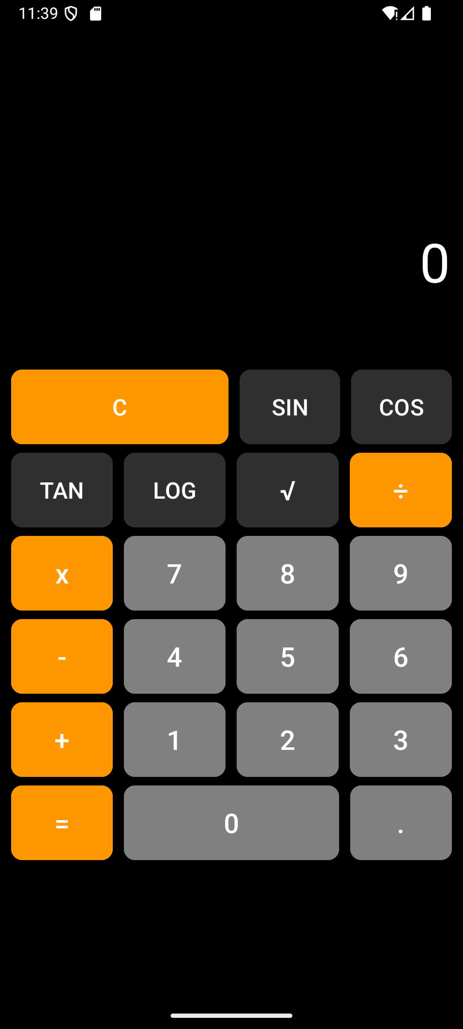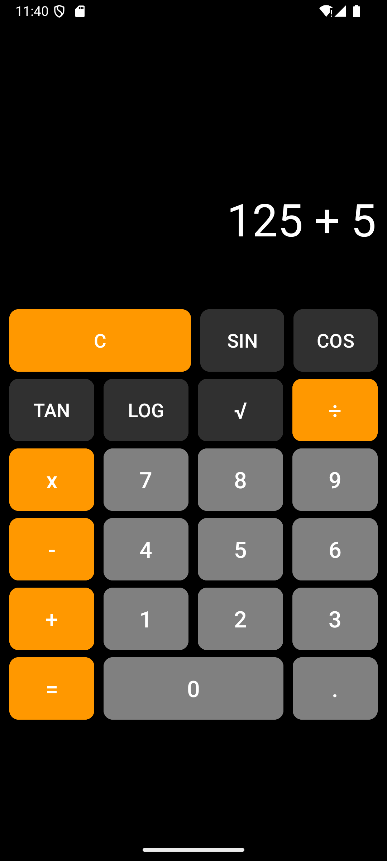

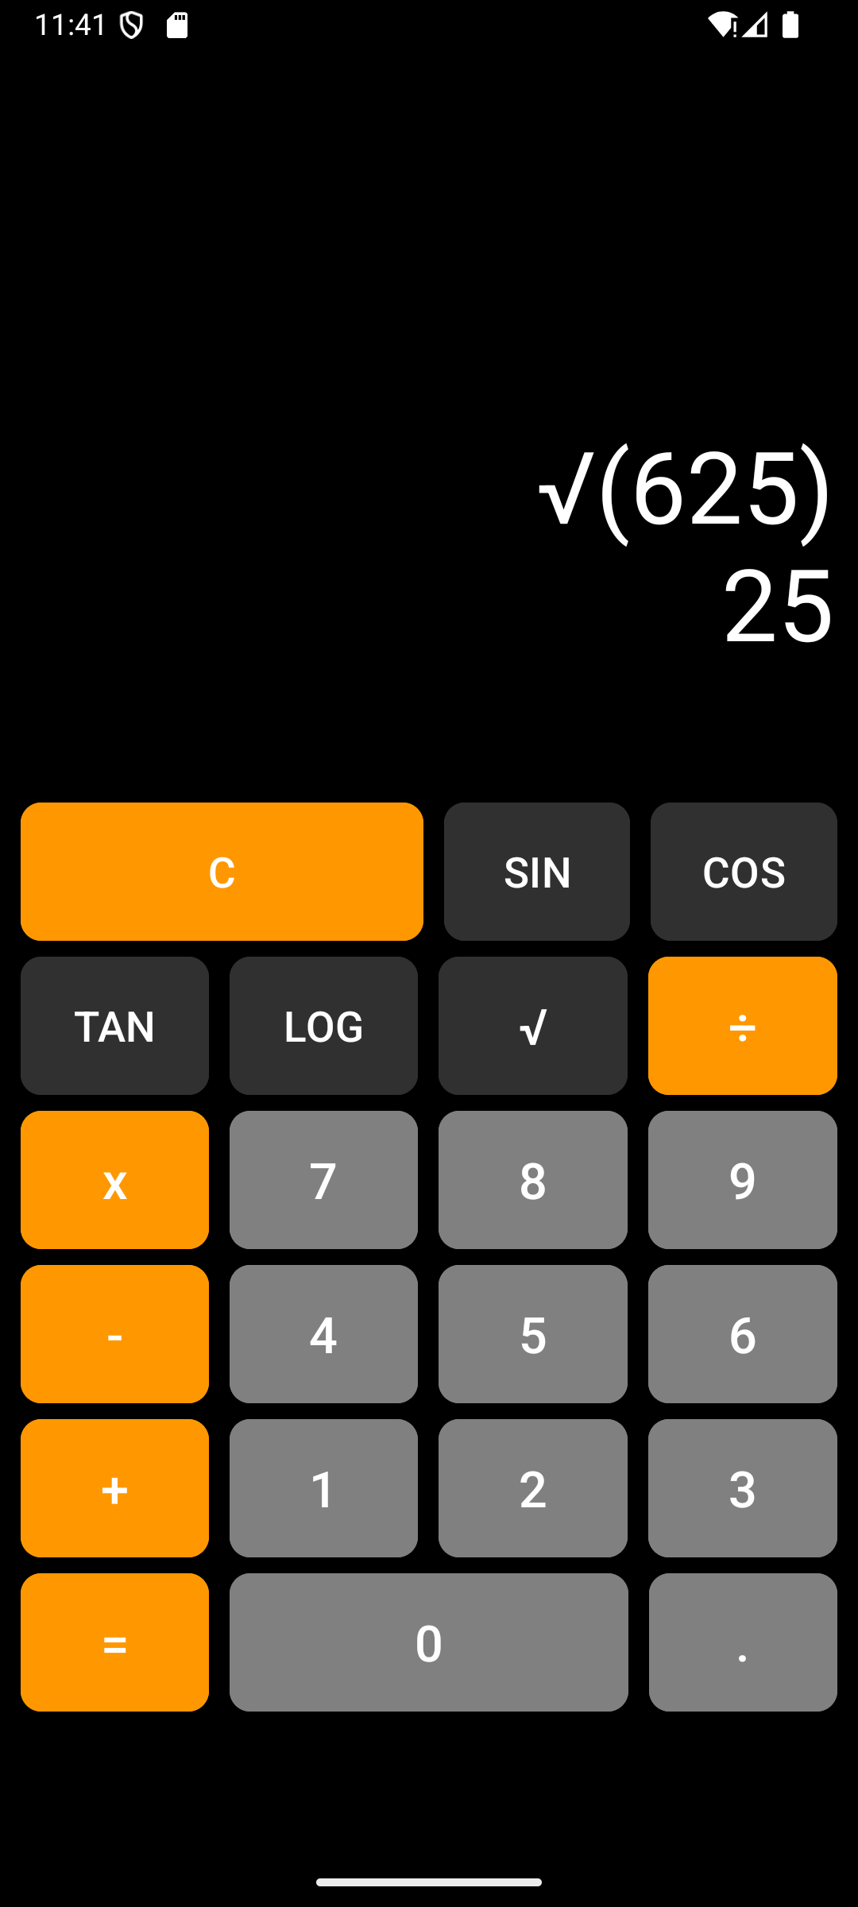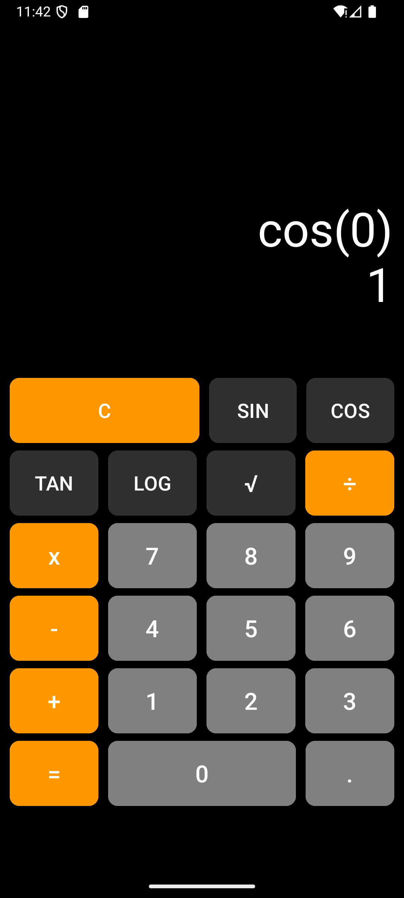

Result:
The scientific calculator application was successfully developed, and it performs arithmetic and scientific calculations correctly with proper display of results.

